School Cash Online
Please note, to avoid confusion, all PAC fees and forms are separate from the school, and not paid online at this time - Please pay the cash directly to the PAC volunteers or insert through the drop box beside the PAC KITCHEN DOOR.

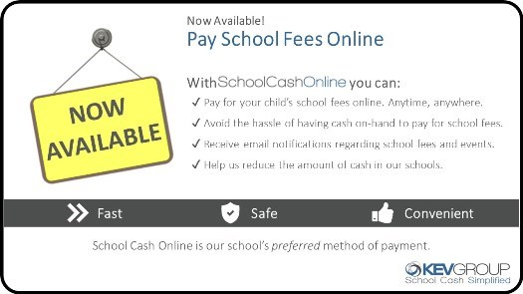
SYNOPSIS ~
- All payments for students' field trips, planners, classroom supplies, fees etc. MUST be paid ONLINE...NO CASH accepted.
- Permission forms must be filled in, signed, and returned to your child's teacher before making a payment.
- Please click on the link below to register or access SchoolCashOnline.
- Please note on the SchoolCashOnline homepage, for your convenience, a Language selection is available at the bottom left, to conveniently translate the webpage to a language of your preference.
- Names and birth dates MUST match the school's information in the Ministry of Education's database (example ~ "Legal" Surname might be different from "Usual" Surname). If you have any problems or trouble attempting to register your child, please contact the school secretary at melanie.carey@mpsd.ca) or phone her at 604-826-6528 to get your child's School Student ID number, which simplifies the data entry for you.
- Please note that SchoolCashOnline does NOT retain or store your banking information for security and privacy reasons.
- PAC fees and forms are separate from the school, and not paid online at this time.
Thank you for your cooperation!
Here's how to get started:

Go to https://mpsd.schoolcashonline.com/ or click here:
- Click on "Get Started Today"
- Create your account
  - Enter first and last name; click continue
  - Enter fields: address, phone number, e-mail address; click continue
  - Choose a password and security question
  - Make sure to OPT IN to receiving e-mail notifications for updated school information
  - There is a toll-free HELP phone number on the SchoolCash website if you have any trouble with registering or paying.

