École Christine Morrison Elementary
AA*' Mission 32611 McRae Avenue, Mission, BC V2V 2L8 Public Schools Phone: 604-826-6528 Fax: 604-82&9175
Website: http://morrison.mpsd.ca
Principal: Shirley Gibson & Vice-Principal: Shannon Greig
13, 2020
Bonjour,
We have rescheduled the ski/snow board days, as our transportation department and Superintendent have given us the
green light.
The new ski/snow board dates are as follows:
- Monday, March 9th
- Monday, March 30th
On both days the bus will leave from our school at 8:15am and return to the school at 5pm.
Thank you for your patience and flexibilty with the unforseen events this year.
If you have any questions, please feel free to contact me at shannon.greig@mpsd.ca .
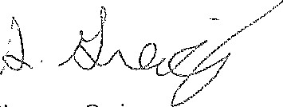
Shannon Greig
Vice-Principal
"Soaring Together....Learning Forever"
"S'elancer conjointement...Apprendre continuellement"

