

**MPS_Logo_Email_Signature**

**Principal: Shirley Gibson Vice-Principal: Shannon Greig**

February 28th, 2020 Newsletter

Dear Parents and Guardians,

**Upcoming Events**

Feb 28 – Early dismissal (11am)

Mar 11 – Parent/Teacher Conf

1pm Spring Music Show

Mar 12 – BC Lions Presentation

at 10:35

Last day before Spring

Break

Mar 30 – School Reopens

Apr 10 – Good Friday

(no school)

Apr 13 – Easter Monday

(no school)

Apr 27 – Rollerblading Unit

Begins

May 07 – Gr 6 immunization

May 15 – Pro D Day (no school)

May 18 – Victoria Day

(no school)

May 25 – Welcome to

Kindergarten

8:45am – 10:15

May 28 – PM performance

Theatre

Jun 15 – Lacrosse Week

Jun 18 – Grade 6 Farewell

Jun 19 – Final Assembly

National Indigenous

People Day

Jun 23 – Primary Sport Day

Jun 24 – Intermediate Sport Day

Jun 25 – Last day for students

Jun 26 – Administration Day

It is hard to believe that Spring is almost upon us and will be here in less than a month. Daylight Savings is around the corner, March 8th, and the longer afternoons will be very enjoyable.



[This Photo](https://tonyburgess1969.net/2019/03/09/its-time-to-spring-forward-daylight-saving-time/) by Unknown Author is licensed under [CC BY-SA-NC](https://creativecommons.org/licenses/by-nc-sa/3.0/)

February was certainly a busy month with Archery, Skiing and the Pink Shirt Day Assembly. The Volleyball season began, and we have three teams this year, which is a great turnout! Our Reading Link Challenge, school based, was held and it was a riveting competition. We had six teams compete and the students had clearly prepared well and answered very challenging questions about the various novels they had read. The Reading Link Challenge continues, and the team who won, Kenny and the Carrot, are moving forward to the district competition on April 3rd. Good Luck!

During the week of March 9th to 12th, our teachers are arranging the Parent/Teacher Interviews for the second term reporting period. Report cards will be sent home on the 9th at the end of the day. Student planners continue to be a key part of home/school communication including any assignments owing and daily work coming home. If you would like to contact your child’s teacher, we have a list of staff on our school website that have direct links to the staff. If you prefer, you are welcome to contact the office and we will ensure the teacher knows you would like them to call you.



[This Photo](https://photomatt7.wordpress.com/2012/10/15/the-report-card-wow-factor/) by Unknown Author is licensed under [CC BY-NC-ND](https://creativecommons.org/licenses/by-nc-nd/3.0/)

For Parents of Grade 4 students, the 2019-2020 Student Learning Survey is now available online. This survey gives the school very important information and is used in a variety of ways. Please see page 2 of this newsletter for further information.

As always, if you have any questions or concerns, please do not hesitate to contact us.

Shirley Gibson and Shannon Greig

## Student Learning Survey 2019/2020 – Grade 4 Students, Parents and Guardians

The Provincial Student Learning Survey is unique in its scope, size and usefulness to schools. It gathers information from parents, teachers and students on topics related to school environment, safety, and achievement. The information is used for planning in individual schools and provides a district and provincial perspective.

Early in **2020** the Student Learning Survey will be administered to students in grades 4, their parents, and all school staff. We encourage parents to participate in this survey, as the results are important in identifying and celebrating current strengths, as well as determining where the school needs to focus improvement. The surveys contain standard questions for the Province – in addition, questions from the school and/or district that focus on local conditions or issues may be included.

The survey can be completed electronically and can be accessed on the Internet at <http://www.bced.gov.bc.ca/sat_survey>. Any computer with an Internet connection can be used, and access to the e-survey is simple and secure. All that is required is a logon number that the school will provide to participants. Provincial, District and School Reports for previous years can be viewed at the same site under the *Results* section. Please contact [shannon.greig@mpsd.ca](mailto:shannon.greig@mpsd.ca) for the login code if you are a parent or guardian of a student in grade 4 and would like to participate in the survey.

The school will be open after school for parents who would like to participate but do not have access to a computer.

**Athletics**

**Skiing/Snowboarding**

The new dates for skiing/snowboarding for our 5/6 students are:

1. Monday March 9th
2. Monday March 30th

The bus leaves Christine Morrison at 8:15am and returns at 5pm

**Volleyball**

March 5th is the date of our final tournament. Best of luck to our 3 teams from our grade 5 and grade 6 classes!

* On March 5th we will have a Vancouver Warriors lacrosse player at our assembly.
* On March 12th We will have a BC Lions football player at our assembly.
* Track and field will be starting in April for our grade 4 – 6 students.

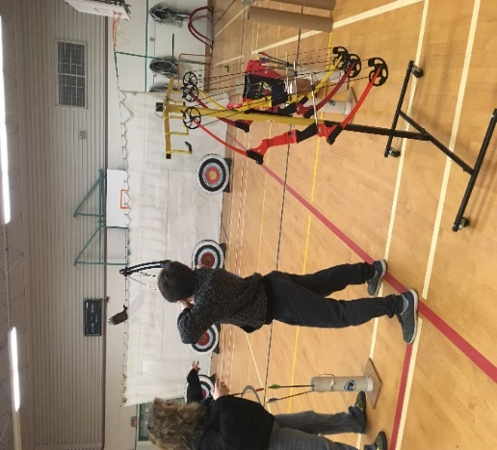

Our grade 5/6 students enjoyed trying out Archery, it was a terrific opportunity!

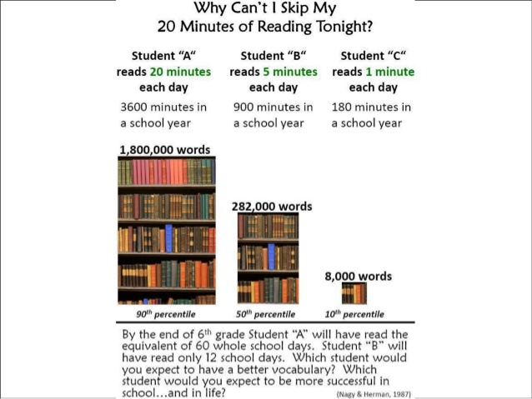 **Daily Reading**

Please continue to read with your child(ren) at home for a minimum of 20 minutes a day and chat with them about what they read. Daily reading has a very powerful impact upon your child’s learning from strengthening their creativity to increasing their vocabulary and it is a wonderful chance to have a chat and engage in a discussion about their day. Please remember that if your child is struggling with concepts, continue to encourage them and emphasize that everyone has areas that they need to work hard in, and perseverance will make all the difference.

**E.C.M.E. Spirit Days**



[This Photo](http://megustalaclasedereligion.blogspot.com/2012/03/feliz-dia-de-san-patricio.html) by Unknown Author is licensed under [CC BY](https://creativecommons.org/licenses/by/3.0/)

**Thursday March 12th** – Saint Patrick’s Day (wear green!)



[This Photo](http://in5d.com/everything-is-backwards/) by Unknown Author is licensed under [CC BY-NC](https://creativecommons.org/licenses/by-nc/3.0/)

**Thursday April 30th** – Backwards day



[This Photo](https://www.flickr.com/photos/bettybroadbent/3516027752) by Unknown Author is licensed under [CC BY-SA-NC](https://creativecommons.org/licenses/by-nc-sa/3.0/)

**Thursday May 14th** – Silly socks day



**Tuesday June 16th** – Superhero day



**Join us for these important sessions!**

Did you know? Our community’s biggest strength lies within our youth and their RESILIENCY. Come and connect with fellow parents and engage in a conversation about our youth over light refreshments. You will have an opportunity to:

• Connect with other parents of youth of similar age

• Get answers to specific questions

• Learn valuable information that may directly affect your child.

February 19 - Cyber Safety with Merlyn Horton

March 18 - Personal Safety & Weapons with TBA

April 5 - Gender & Population Diversity with Pierre Richez

May 20 - Vaping with Emily Hunn

**Where**? Mission Community Activity Centre 33100 10th Ave Mission

**When**? Wednesdays, 6:30 - 8:30pm

For more information, contact Chelsey (Rec Leader Youth) at: 604-814-1267 or [chogness@mission.ca](mailto:chogness@mission.ca)

**Fraser Valley Regional Library News!**

**LEGO Club**

Tuesdays, 3 pm – 4:15 pm

**Discovery Club (Please register online, ages 8-12)**

1st & 3rd Wed of the month, 3:30 pm - 4:30 pm

Come and get excited about science, technology, engineering, art and mathematics - STEAM. There will be tinkering, coding, creating, experimenting and designing.



**BeTween the Pages Book Club ((Registration required, ages 9-12)**

2nd Wednesday of the Month, 3:30 pm - 4:30 pm

**Paws 4 Stories (Registration required)**

3rd Thursday of the month, 3:30 pm – 4:30 pm

**Beginner’s Ukulele (please register online, ages 8-12)**

Mondays, March 16 and 23, Wed Mar 18 and 25, 11:00am -12:00pm

This Spring Break program is for ages 8-12 and is taught by a music instructor. Ukuleles will be provided.

**Raptor’s Ridge**

Thursday, March 19, 10:30-11:30 am

Raptors Ridge will offer a rare and unique opportunity to view birds of prey up close and personal. Fun for the whole family.

**Spring Break Special: Science World on the Road**

Friday, March 20, 2 pm – 3 pm

**Go Big or Go Home: Giant Games**

Saturday, March 28, 10 am – 4:30 pm

Drop by and play our collection of giant-sized games, including Snakes & Ladders, Bananagrams, and more.